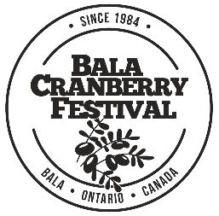
2023 APPLICATION FOR COMMUNITY FUNDING
Requests must be received by November 30th 2023

In 2023, we were happy to receive government funding from the Province of Ontario, that helped support some of the costs to host our beloved festival. Due to this funding provided to cover expenses we will have a small amount of Community Funding available. We appreciate all the effort that many not for profits do for the Township of Muskoka Lakes community. A focus on the community involvement, and volunteer support of the festival will be taken into account, when allocating funds. Funding will be made available from the 2023 year at the AGM in February 2024.

Non-Profit Organization:
Mailing Address
City | Postal Code
Contact Person | Business Phone
Email Address | Home Phone
If awarded community funding, legal name to be written on cheque: (Please note that a Cheque cannot be written to an individual)

Funding:
Have you received funding from the Cranberry Festival in the past 5 years? YES / NO
If so, how were those funds applied by your organization? Please use a 2nd page if needed:
Requested amount of funding for 2023: $
Explanation for use of funding. Please be goal specific and include notes on how the funding will be used for residents in the Township of Muskoka Lakes Community including specifics costs, i.e Ice rental time, jersey cost, etc. (Please use a 2nd page if needed, and any quotes from suppliers):
Volunteering Support:
Did your group volunteer for the 2023 Bala Cranberry Festival? YES/NO
If yes what areas did members of your group assist in: (Names if possible and shifts covered)
Grant Recognition:
If your group is successful in receiving financial support, how will the funding contribution be recognized?
SIGNATURE: | PRINT NAME:

Please attach a current Balance Sheet and Profit Loss report from most recent fiscal year– Failure to attach may result in a denied application
We thank all the groups that apply for funding. The selection committee will review all applications and the total funds available for disbursements in December & January. Applicants will be notified by email.
IN ORDER FOR YOUR APPLICATION TO BE CONSIDERED, PLEASE MAIL, OR EMAIL PRIOR TO THE DEADLINE
PO Box 72, Bala, ON, P0C 1A0
Ph: 705-762-1564
cbfest@muskoka.com

